Connecting to managed AWS services

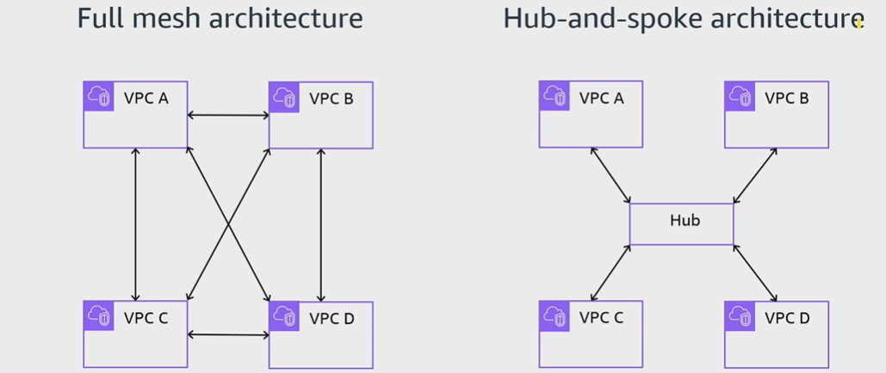
A. Network design with multiple VPCs

B. AWS Transit Gateway
- Is a centralized, Regional router to connect VPCs and on-premises networks based on hub-and-spoke architecture.
- is a managed AWS service that automatically scales based on the volume of network traffic.
- Can be peered with other trasit gateways in other AWS Regions and AWS accounts.
- Incurs cost charges based on the number of connections and amount of traffic throughput.
- Has a Transit Gateway Flow Logs feature to publish transit gateway traffic logs.

C. Centralized VPC routing pattern
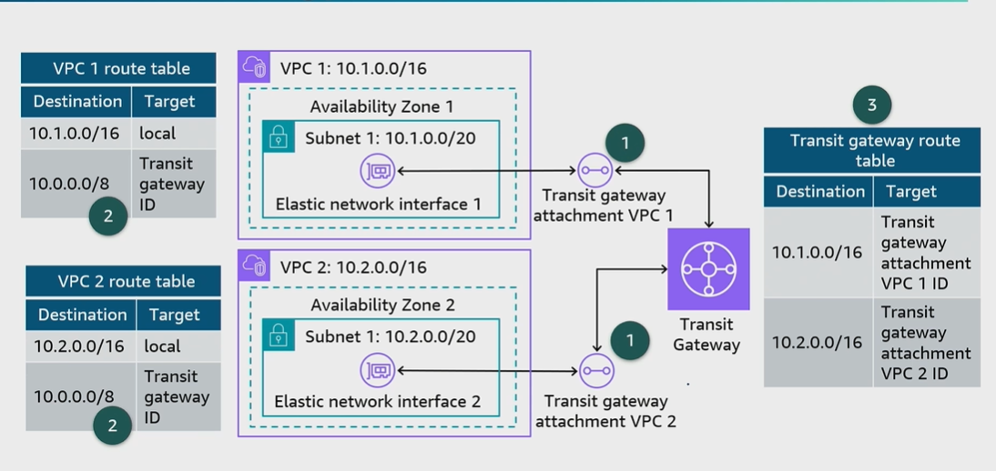
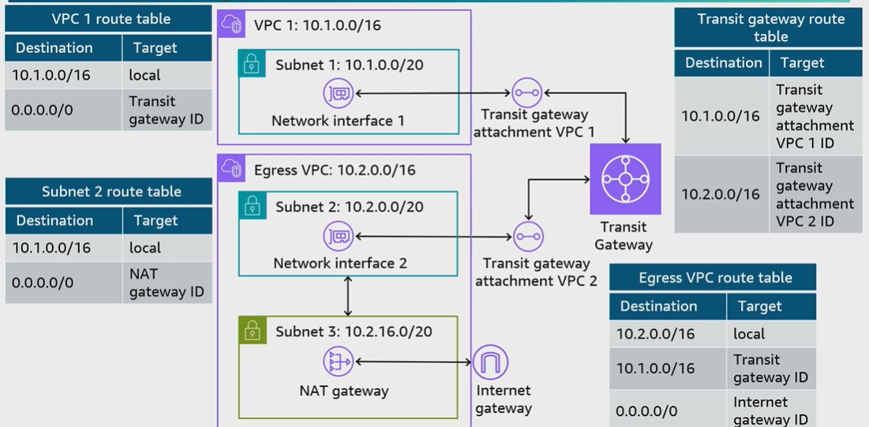
D. Centralized routing pattern for outbound traffic

E. Transit gateway peering
